ΟΝΟΜΑΤΕΠΩΝΥΜΟ:___________________________________26-3-2020
Μπορείς να αναλύσεις τον αριθμό, όπως στο παράδειγμα;

564=500+60+4 | 650=
876= | 455=
901= | 111=
321= | 752=
Πόσο κάνει;

700+80+3= | 900+9=
400+4= | 200+10=
400+40+4= | 700+4=
600+20+1= | 800+20+8=
Ποιος είναι ο ακριβώς προηγούμενος
και ο ακριβώς επόμενος αριθμός;

,600, | ,403,
,799, | ,333,
,210, | ,909,
,789, | ,101,
Γράψε δίπλα σε κάθε σχήμα
και στερεό, πώς λέγεται.

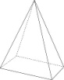
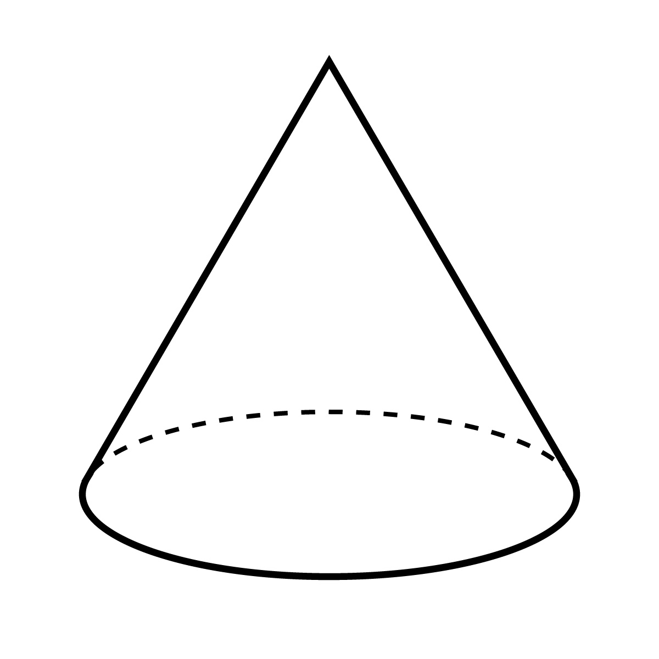

Γράψε κάθετα τους αριθμούς
και πρόσθεσέ τους.

56+34 | 82+19 | 87+35 | 43+28 | 54+7+25
312+654 | 765+21 | 980+20 | 605+7 | 867+12+8

Ποιος ή ποιοι αριθμοί λείπουν;

3x8= | 4x4= | 12:3= | X =64
4x4= | 3x3= | 56:7= | X =12
6x6= | 3x7= | 32:4= | X =55
8x8= | 2x2= | 64:8= | X =16
4x9= | 6x8= | 42:6= | X =21
3x4= | 5x6= | 18:3= | X =56
4x6= | 8x9= | 49:7= | X =32
9x9= | 3x9= | 81:9= | X =49
3x6= | 7x7= | 24:3= | X =100
6x9= | 8x5= | 28:4= | X =0
6x7= | 4x8= | 24:6= | X =24
7x9= | 2x11= | 21:3= | X =36

